Software Design Approaches - Data-Oriented

📖 Definition
# Source: AI Source: Provided by: [Data Path: Persons Table -> ID Column: 1, Name_En Column: Motasem Essam] -> From: [ChatGPT] on [1/23/2026]
Data-Oriented Design (DOD) is a software design approach that focuses on organizing data efficiently and optimizing how it is stored, accessed, and processed to achieve high performance.
👉 In simple terms:
“Design software around data and how it flows, not around objects.”

⚙️ How It Works
# Source: AI Source: Provided by: [Data Path: Persons Table -> ID Column: 1, Name_En Column: Motasem Essam] -> From: [ChatGPT] on [1/23/2026]
- Identify the data required for the system
- Organize data into efficient structures (arrays, structs)
- Optimize for sequential memory access
- Design systems that transform data step by step
- Minimize unnecessary abstractions

🧩 Key Characteristics
# Source: AI Source: Provided by: [Data Path: Persons Table -> ID Column: 1, Name_En Column: Motasem Essam] -> From: [ChatGPT] on [1/23/2026]
- Focus on data layout in memory
- Uses contiguous data structures (e.g., arrays)
- Emphasizes cache efficiency
- Reduces object overhead and indirection
- Encourages simple, flat structures

🧠 Core Concepts
# Source: AI Source: Provided by: [Data Path: Persons Table -> ID Column: 1, Name_En Column: Motasem Essam] -> From: [ChatGPT] on [1/23/2026]
📊 Data Layout Optimization
- Store related data together in memory
- Improves CPU cache utilization
🔁 Sequential Processing
- Process data in a predictable, linear order
- Reduces random memory access
⚡ Cache-Friendly Design
- Align data with CPU cache lines
- Fewer cache misses → faster execution
✂️ Minimized Abstraction
- Avoid deep inheritance or complex object hierarchies
- Focus on performance over structure

✅ Advantages
# Source: AI Source: Provided by: [Data Path: Persons Table -> ID Column: 1, Name_En Column: Motasem Essam] -> From: [ChatGPT] on [1/23/2026]
- High performance (especially for real-time systems)
- Better memory and cache efficiency
- Easier parallel processing (multi-threading, SIMD)
- Reduced overhead from objects

⚠️ Disadvantages
# Source: AI Source: Provided by: [Data Path: Persons Table -> ID Column: 1, Name_En Column: Motasem Essam] -> From: [ChatGPT] on [1/23/2026]
- Less intuitive than object-oriented design
- Can reduce code readability
- Requires knowledge of low-level memory behavior
- Not ideal for all applications (e.g., business systems)

🎯 Use Cases
# Source: AI Source: Provided by: [Data Path: Persons Table -> ID Column: 1, Name_En Column: Motasem Essam] -> From: [ChatGPT] on [1/23/2026]
- Game development (e.g., engines like Unity)
- Real-time simulations
- Graphics programming
- High-performance computing (HPC)
- Embedded systems

🛠️ Simple Example
# Source: AI Source: Provided by: [Data Path: Persons Table -> ID Column: 1, Name_En Column: Motasem Essam] -> From: [ChatGPT] on [1/23/2026]
🔹 Object-Oriented Approach:
- Player object → position, velocity, health
🔹 Data-Oriented Approach:
- positions[]
- velocities[]
- health[]
👉 This allows processing many players faster and in parallel.

🔄 DOD vs Object-Oriented Design (Quick Insight)
# Source: AI Source: Provided by: [Data Path: Persons Table -> ID Column: 1, Name_En Column: Motasem Essam] -> From: [ChatGPT] on [1/23/2026]
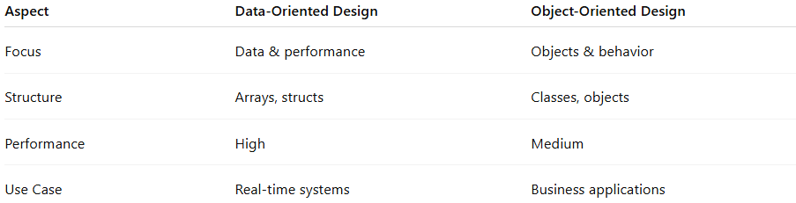
Aspect | Data-Oriented Design | Object-Oriented Design
Focus | Data & performance | Objects & behavior
Structure | Arrays, structs | Classes, objects
Performance | High | Medium
Use Case | Real-time systems | Business applications

📌 Summary
# Source: AI Source: Provided by: [Data Path: Persons Table -> ID Column: 1, Name_En Column: Motasem Essam] -> From: [ChatGPT] on [1/23/2026]
Data-Oriented Design (DOD) focuses on efficient data handling and memory usage to maximize performance. It is widely used in high-performance and real-time systems, where speed and efficiency are critical. While powerful, it requires a deeper understanding of how software interacts with hardware and may reduce code readability compared to traditional approaches.

